Tracey Schultheis – 443-553-3124
tschultheis@zoominternet.net
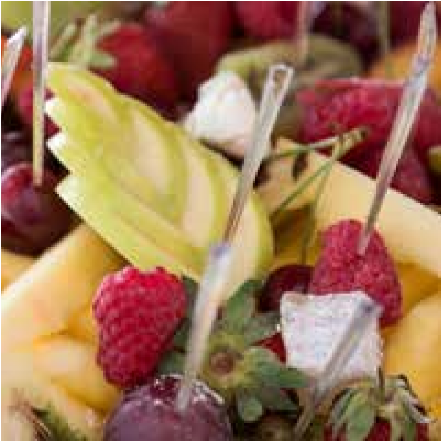
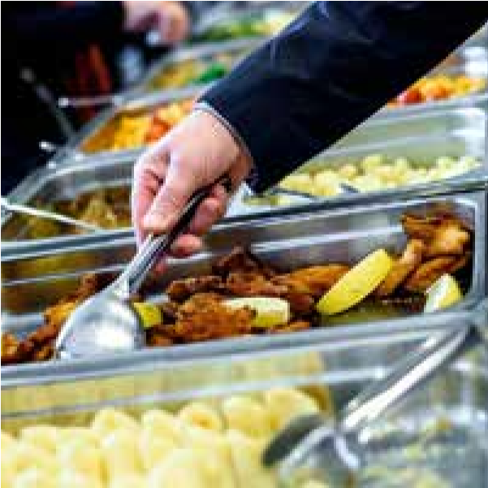
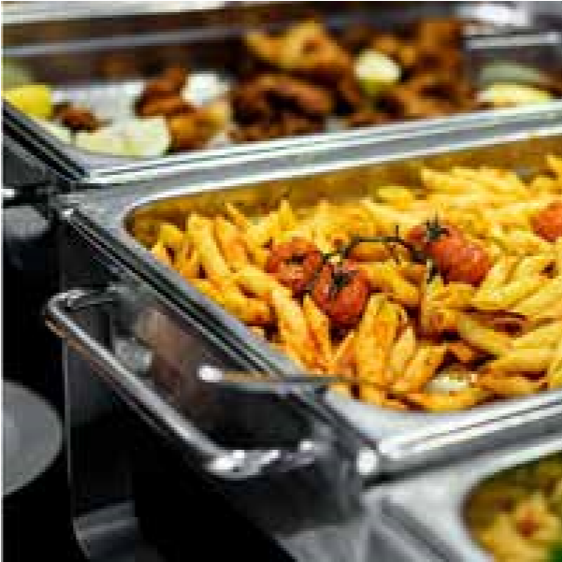

Hors d’Oeuvres:

Nacho Bar
Tortilla chips, sour cream, salsa, guacamole, warm cheddar cheese, jalapenos, soda & water –
$9.50 / person

Simple
Meatballs (Marinara or Swedish), cheese & crackers, hummus with pita bread, cookies, brownies, lemonade, iced tea & water - $10.50 / person

Upscale
Charcuterie & cheese with crackers, hot crab au gratin with crostini, bruschetta, roasted vegetable platter with hummus, finger desserts, coffee, iced tea & water - $13 / person

Sweet Tooth
Brownies, cookies, finger desserts, coffee, lemonade & water $9.50 /person

a la Carte
Meatball bar — Swedish, marinara, sweet & sour –
$9.50 / person

Popcorn bar — Caramel, butter, & white cheddar with pepper, garlic & rosemary - $2.50 / person

Soft pretzel bites served with cheddar ale fondue & assorted mustards - $3.50 / person

Boneless Wing bar — Buffalo, BBQ & Asian, served with carrots, celery, ranch & blue cheese dressings - $6 / person

International Cheese & Charcuterie served with Grape Clusters and Crackers -$6 / person

Chilled shrimp cocktail display - $5.50 / person

Shrimp or seafood & fresh citrus ceviche - $5 / person

Mediterranean bar - olives, hummus, pita, fresh mozzarella & feta cheeses, & roasted vegetable display - $6 / person

Roasted vegetable display or classic vegetable crudité
with assorted dips - $4 / person

Bruschetta Bar — tropical & traditional with crostini
& tortillas - $4 / person

Dips — Hot crab au gratin, hot or chilled spinach & parmesan, buffalo chicken, South of the Border, Hummus, Pita, & Chilled Spinach in Bread Bowl (select 3) -
$6.50 /person

Mac & Cheese Bar $6.50 /person

Breakfast:
Continental — assorted breakfast pastries, donuts & bagels with cream cheese, jam & fresh fruit salad – $8 / person

Burrito Bar - scrambled eggs, bacon, sausage, cheese, salsa, tortillas, & fresh fruit salad - $12 / person

Classic - scrambled eggs, sausage, bacon, breakfast potatoes, breakfast breads with butter & jelly, and fresh fruit salad - $15 / person

Frittatas - regular & egg white, breakfast breads with butter & jelly, & fresh fruit salad - $12 / person

Parfait Bar - assorted yogurts, granola, nuts, hard boiled eggs, cottage cheese, fresh fruit salad & breakfast breads with butter & jelly - $10 / person

Lox-smoked salmon, bagels, capers, cream cheese, fresh fruit salad, & cold quinoa & yogurt porridge $11.50 / person

Breakfast Add-ons:
Belgian Waffle Bar - $4 / person
French toast casserole - $3.50 / person
Sausage or chipped beef gravy with biscuits - $4.00 / person*All breakfast options include juice assortment & coffee*

Lunch & Dinner:
Mac & Cheese Bar - choose two: 5 cheese mac, gorgonzola mac, cauliflower mac - accompanied by sundried tomatoes, green onions & bacon – includes artisanal rolls & 2 green salads - $13 / person

Sandwiches / Wraps — turkey, ham, roast beef, chicken salad, bread assortment, condiments, lettuce, tomato & pickles choice of green & specialty salad— sandwiched can be pre-made or make your own - $13 Boxed / person

Lunches — assorted turkey, ham, roast beef & vegetarian sandwiches or wraps, with chips, brownie or cookie & fruit or caesar salad - $12 / person

Slider bar — choose three: traditional beef, buffalo chicken, Jerk Chicken, pulled pork, brown rice & zucchini (substitute crab cakes for an additional $5)— includes rolls, condiments, one green salad, coleslaw, or potato salad –
$16 / person
Gyro bar — chicken shawarma & lamb, pita, shredded lettuce, tomato, onion, sour cream, tzatziki, Greek salad & fresh steamed vegetables - $15
Build Your Own Meal: Choose 1 from each section:
- Chicken Piccata, Bacon & Swiss Roulade with Tarragon Panko, Chicken Parmesan, Herb & Hummus Crusted Chicken, or Mediterranean Chicken (Choose 1)
- Rice Pilaf, Herb & Garlic Roasted Red Potatoes or Balsamic Blistered Cauliflower (Choose 1)
- Roasted Green Beans or Fresh Steamed Vegetable Medley - includes one green salad, roll & bread assortment (Choose 1)
$16.50 / person

Steak and Seafood Option:
Crab cakes, marinated, grilled & carved flank steak, rice pilaf or herb & garlic roasted red potatoes, fresh steamed vegetable medley, one green salad, roll & bread assortment –
$31 / person

Lunch & Dinner add-ons:
Brownies & cookies - $3.50 / person
Finger desserts - petite cream puffs, cannoli’s, assorted dessert bars, brownies, and petite cheesecakes $4.50 / person
Cupcake, pie, or cake assortment - $4.50 / person
Choice of soup — (see selections and prices on page 4) *all lunch options include lemonade, iced tea & water*
*Green salad options on page 4*

Menu continued - next page:

From the Grill:
Traditional cookout - hot dogs, hamburgers, veggie burgers, rolls, & condiments - $13 / person

Traditional pit cookout - pit beef, pit turkey, veggie burgers, rolls, & condiments - $16.50/ person

Fajita cookout - marinated grilled chicken, grilled vegetables, tortillas, carne asada & condiments –
$18.50 /person

Southern BBQ - pulled pork or pulled BBQ chicken, rolls, & condiments - $14 / person

Texas BBQ - brisket, sausage, and Chicken -white bread, onions, & pickles and assorted sauces - $22 / person

*Choose 2 accompaniments - Choices located on page 4*

Comfort Food:
Cider brined roasted chicken, braised beef short ribs in a red wine & tomato reduction, with one side, one salad, & rolls with butter- $22 / person

Traditional beef & bean chili, white chicken chili, corn bread, & one salad - $11 / person

Home style turkey dinner with all the trimmings - $20 / person

Shrimp & Grits, collard greens, & one salad - $16 / person

Southern style fried chicken, 5 cheese mac, potato planks & one salad - $16 / person

*Sides and salad choices located on page 4*

South of the Border:
Taco bar — chipotle shredded chicken, carne asada, yellow rice, refried or spiced black beans & tortillas -$15 / person

Chicken, beef, or bean & cheese enchiladas - $15 / person

Pineapple chipotle pulled pork, mojo chicken, refried or spiced black beans & tortillas - $17 / person

*all served with – shredded lettuce, shredded cheddar cheese, sour cream, homemade salsa, and guacamole*

Trip to Italy:
Chicken parmesan over spaghetti, garlic bread
& one salad - $15 / person
Shrimp Scampi or Fra Diavolo with Garlic Bread and Salad - $15.50 / person
Cheese ravioli or tortellini in rose cream sauce, meatballs, garlic bread, & one salad - $14 / person
Pasta Bar — two pastas, three sauces, meatballs, chicken, garlic bread, & one salad - $17.50 / person

*Green salad options located on page 4*

Asian Flare:
Chicken Pad Thai, white or brown rice, stir fried vegetables, & one salad - $13.50 / person
Vietnamese honey ginger chicken, white or brown rice, stir fried vegetables, & one salad - $14 / person
Korean beef or chicken BBQ, white or brown rice, kimchi & pickled vegetables, & one salad - $15.50 / person
Coconut curry shrimp, rice noodles, stir fried vegetables, & one salad - $15.50 / person
Chicken or steak & vegetable fried rice
& one salad - $14 / person
Shrimp & vegetable fried rice & one salad - $15 / person

*Green salad options located on page 4*

Menu continued - next page:

Soups, Salads and Sides:

Soups:
Pumpkin bisque $4
Tomato bisque $4
Cream of mushroom $4
Minestrone $4
Spicy Chicken Lemongrass with Vegetables $4
Italian wedding $4
Chili (traditional beef & bean, white bean & $4
Chicken or vegan black bean)
Chicken Corn Chowder $4
Crab Bisque* $6
Maryland Crab* $5.50

Green Salads:
- Garden Salad with choice of dressings
- Classic Caesar or Baby Arugula Caesar
- Baby Kale with Pickled Onion, Montrachet Goat Cheese
crumbles, Pepitas, and Dried Cranberries in Cranberry vinaigrette
- Traditional Greek Salad
- Green Mango & Jicama salad with mango vinaigrette
- Chopped salad
- Gorgonzola or Montrachet Goat Cheese salad with seasonal
fruit or berries, candied pecans, crumbled Cheese over
baby greens in a vinaigrette
- Bacon, sundried tomato & blue cheese
- Baby Kale OR Arugula with Pepitas, Dried Cranberries,
pickled onion, and Goat Cheese in Balsamic Vinaigrette
-Tomato Peach Salad over Tender Greens with Ricotta

Please note: Our menu prices are for delivery ONLY. If set up, staffing and clean-up is required, there will be an additional fee.

Sides:

Chilled:
- Redskin potato salad or Cauliflower Potato Salad
- Pesto Pasta Salad
- Old School Macaroni salad
- Fresh fruit salad
- Corn, tomato & black bean salad
- Southern or Asian style slaw
- Mexican Street Corn Salad
- Quinoa & roasted vegetables
- Soba Noodle Salad in Sesame Ginger Dressing
- Middle Eastern Carrot Salad in Garlicky Parsley Aioli

Hot:
- 5 bean baked beans
- Herb & garlic roasted red potatoes
- Roasted root vegetables—turnips, sweet potatoes, parsnips,
& rutabaga in herbed garlic olive oil
- 5 cheese macaroni & cheese
- Cauliflower macaroni & cheese
- Buttermilk mashed potatoes
- Cheddar horseradish mashed potatoes
- Garlic & thyme roasted green beans
- Fresh steamed vegetable medley
- Balsamic roasted Brussel sprouts
- Maple miso glazed baby carrots
- Sea salt dusted Yukon gold potato planks
- Seasonal risottos
- Oven Crisped Brussels in Garlic Fig Jam
- Balsamic Blistered Cauliflower with Garlic and
EVOO

